EXP NO: 03 DATE:

DEVELOP A LEXICAL ANALYSER TO RECOGNIZE A FEW PATTERNS IN C.

(EX.IDENTIFIERS, CONSTANTS, COMMENTS, AND OPERATORS, ETC.) USING LEX TOOL.

AIM:

To develop a Lexical Analyzer using the LEX tool that recognizes different tokens in a given C program snippet, including Identifier, Constants, Comments, Operators, Keywords, Special Symbols.

ALGORITHM:

* Start
* Define token patterns in LEX for:

* Keywords (e.g., int, float, if, else) 
* Identifiers (variable/function names) 
* Constants (integer and floating-point numbers) 
* Operators (+, -, =, ==, !=, *, /) 
* Comments (// single-line, /* multi-line */) 
* Special Symbols ({, }, (, ), ;, ,) 
* Read input source code.
* Match the code tokens using LEX rules.
* Print each recognized token with its type.
* End

PROGRAM: 

 

%{

#include <stdio.h>

#include <stdlib.h>

#include <string.h>

#include <stddef.h>

%}

%%

"int"|"float"|"if"|"else" { printf("KEYWORD: %s\n", yytext); }

[a-zA-Z_][a-zA-Z0-9_]* { printf("IDENTIFIER: %s\n", yytext); }

[0-9]+ { printf("INTEGER CONSTANT: %s\n", yytext); }

[0-9]*\.[0-9]+ { printf("FLOAT CONSTANT: %s\n", yytext); }

\/\/.* { printf("SINGLE-LINE COMMENT\n"); }

\/\*([^*]|\*+[^/*])*\*\/ { printf("MULTI-LINE COMMENT\n"); }

\+|\-|\*|\/|\%|=|==|!= { printf("OPERATOR: %s\n", yytext); }

[\{\}\(\)\;\,] { printf("SPECIAL SYMBOL: %s\n", yytext); }

[ \t\n] { }

%%

int yywrap() {

return 1;

}

int main() {

yylex(); return 0;

}

OUTPUT:

lex lexer.l cc lex.yy.c -o lexer ./a.out Sample Input int main() { int a = 10; float b = 20.5; /* This is a multi-line comment */ if (a > b) { a = a + b; } return 0; }

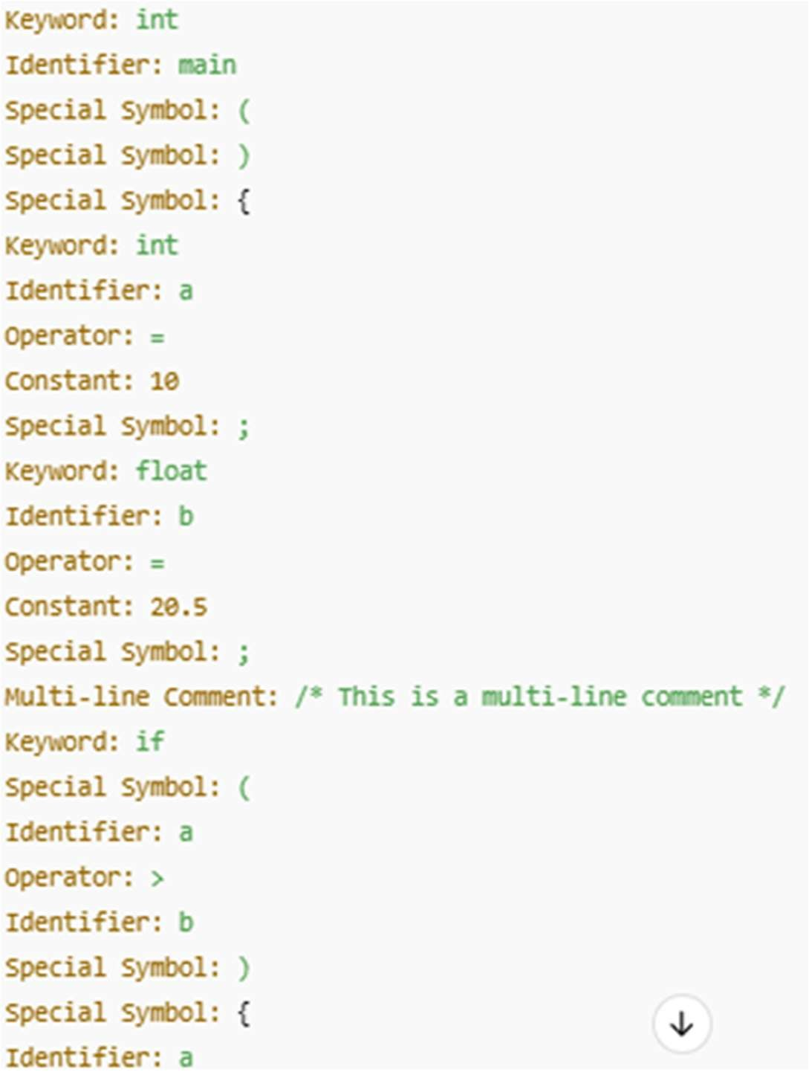

|  |  |
| --- | --- |
| Implementation |  |
| Output/Signature |  |

RESULT:

Thus the above program reads a C code snippet, tokenizes it using LEX rules, recognizes and categorizes keywords, identifiers, constants, operators, comments, and special symbols, and then displays each token along with its type.